Expectations, Procedures, and Policies

For Mr. Hester’s LPS-Richmond Students


Classroom Expectations

- Follow directions the first time they are given.

- Be in the classroom and seated when the bell rings.

- Keep hands, feet, and objects to yourself.

- Use appropriate language; no put-downs, teasing, or

other inappropriate words.

Classroom procedures

A) Homework completion – For homework to be considered complete, all parts of the homework must be complete.

B) Handing in homework – Homework must be handed in to the appropriate place before you enter into the classroom.

C) Entering the classroom – You must enter class silently. Whispering is not allowed.

D) Moving to your seat and Launch – After you have walked through the front door to the classroom silently, pick up any handouts left on the “Pick Up Here” desk. After picking up the handouts, walk to the desk that is assigned to you without talking. Take out your class binder, a pencil or pen, and any other supplies that you will need. Put your backpack to the left of your desk.

E) Quiet signs – If the class is doing an activity but then Mr. Hester needs that class’ attention, he will use different signals to ensure that students are quiet and that the class is paying attention. Three quiet signs are the following:
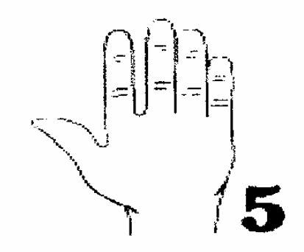
a. Count down from five: In order to get the attention of the class after group work, Mr. Hester will count down from five. At that point you must give Mr. Hester the following five things:

1. Be silent
2. Be still
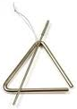
3. Track the speaker
4. Listen to the speaker
5. Have your hands free
b. Triangle and count down from five: Same as the above, but Mr. Hester will hit a metallic triangle to signal that he is going to count down from five.
c. Clap it quiet: When Mr. Hester claps out a rhythm, students in the class put down anything that they are working on, track the clapper, be still, and repeat the rhythm that is clapped. All students must be silent after they repeat the rhythm.

F) What to do when you finish class work early – If you have successfully completed your class work, check it over. After you have finished your work and checked it, you have two options:
a. Sit silently and wait for further instructions.
b. Take out your Accelerated Reader book and read silently. Students will not be able to go up and pick out a book from the classroom library at this time.
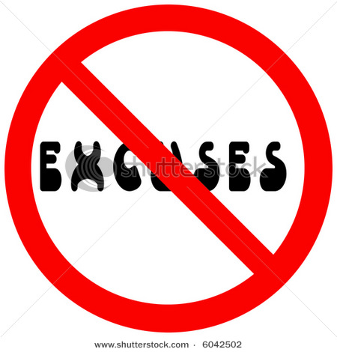
G) Handing in late homework – Unless you are absent, late homework is not accepted. Students who come to class without completed homework will be sent to Homework Center after school.

H) Movement in the classroom – Students must have Mr. Hester’s permission to get out of their seat at any time throughout the class period.

I) Sharpening pencils – Pencils should be sharpened before class begins. If both of your pencils are dull and you need to sharpen your pencil during class, raise your pencil in the air. If Mr. Hester gives you permission to sharpen your pencil, only then may you quietly walk to the pencil sharpener to do so.

J) Blowing your nose – If you need to blow your nose, raise one of your hands and touch your nose with the other. If we are at an important moment in the lesson, Mr. Hester will ask you to wait. You may not leave the classroom to blow your nose.


K) Bathroom – The best idea is to use the bathroom during the break between classes. If you need to use the bathroom during class, hold up one of your bathroom passes in the air. Mr. Hester will then let you know whether or not you can go to the bathroom at that time. For your pass to be good, your own name must be clearly printed in ink on your bathroom pass, and there must not be any other name scratched out. Students who need to use the bathroom but who do not have a pass will serve a detention.

L) Throwing out garbage – All garbage is to be kept at your desk until the end of class. At the end of class, take your trash as well as any scraps on the ground near your desk and place them in the trashcan.

M) Getting the teacher’s attention – If a student needs to speak with Mr. Hester, that student should raise their hand but not call out with their voice.

N) Required supplies – Come to class prepared with the proper supplies. The first item you need to bring is your English binder that includes two pencils and two pens. You should also bring your Accelerated Reader book. Students are not allowed to leave class for supplies or books once class has begun.

O) End of class dismissal – Mr. Hester, not the sound of the bell, will tell the class when it is time to get ready to go. When Mr. Hester says “Time to clean up,” that means that all students should silently pack up their belongings and stand up next to their chair. When Mr. Hester says, “Have a good day,” then students may leave the classroom or talk with Mr. Hester if they have questions.

P) Fire/Earthquake/Emergency – For emergency drills and real emergencies, we will remain calm, leave the classroom, and walk to the appropriate place as one group. As we walk together, no students should separate from the class group.

Q) Cheating policy – Cheating cheats you out of your own education. Cheating doesn’t help you learn, and we are here to learn. The minimum punishment for cheating will be a zero on that assignment, homework center, and a phone call home.

R) Visitor policy – Because we are a class with big goals and that will achieve great results, we will have more visitors in our classroom than normal. Do not be distracted by visitors, but instead, show them why we are the most successful English class in all of West Contra Costa.

Classroom policies

- Students must sit where they are placed on the seating chart. There are no exceptions to this rule.

- I will take any electronic device or related item that I see or hear. Electronic devices and related items are iPods, headphones, cell phones, video game players, etc. There will be no warnings given and there is no room for negotiation. Each time I take an electronic item from you it well be left in the office.

- No hats, beanies, do-rags, or hoods may be worn after you cross the door to the classroom. Each time that you have one of the aforementioned items on in the classroom it will be taken from you and held in the office. There will be no warnings given and there is no room for negotiation.

- No food or drink besides water in a clear bottle is allowed inside of my classroom. This includes sunflower seeds.

- Make up, compacts, lotion, mirrors and any other beauty products are not allowed in class and will be taken and kept in the office.

- Gum is never allowed in class. Any student who is chewing gum in class will be given a consequence, must throw the gum away, and will have lunch detention with Mr. Hester.

Grading System*

Major Tests and Essays:_________________ 50% of grade
Class Preparation and Participation:________ 5% of grade
Accelerated Reader:____________________ 10% of grade

Quizzes:______________________________ 20% of grade

Homework:____________________________ 15% of grade

*Subject to change.

Consequences for choosing to meet or exceed the expectations:

- The joy of learning

- Verbal praise

- Merit points

- BHAG Tickets

What you can earn with BHAG Tickets
- 1 BHAG ticket
  - Glitter pound

- 2 BHAG tickets

  - Positive call home
  - Positive note home

- 3 BHAG tickets
  - Scholar prize bin
  - 1 merit point

- 4 BHAG tickets
  - Mr. Hester buys you a book of your choosing.
  - 2 merit points

Consequences for choosing to not meet the expectations:

- Verbal or visual warning.

- After-class, during-lunch, or after school meeting with Mr. Hester (and possible call home)

- After-class, during-lunch, or after school meeting with Mr. Hester, and a call home

- After-class, during-lunch, or after school meeting with Mr. Hester, a call home, and referral to dean.

Student Binders
Each day, students will bring their English binder with them to class. The size of the binder should be 1.5 inches. The contents of the binder should be the following (in order):

- A pencil pouch with the following contents:
  - Two pencils
  - Two pens
  - Two extra erasers.
  - Suggested: pencil sharpener.
- Five dividers with the following names:
  - Notes
  - Vocab + Roots
  - Grammar
  - Writing
  - BHAG Tests and Trackers
- At least 100 sheets of loose leaf paper

9th grade Year Long Plan*

The units:
- Unit 0: Introduction to classroom systems and procedures plus culture (~2 weeks)
- Unit 1: The House on Mango Street / Narrative (7 weeks)
- Unit 2: The Boy in the Striped Pajamas or Night / Response to Literature (6 weeks)
- Winter Break
- Unit 3: Romeo and Juliet / Persuasion (9 weeks)
- Unit 4: Informational Materials and Poetry Unit (~2.5 weeks)
- Unit 5: Greek Gods and Goddesses Mini Unit (~1 week)
- Unit 6: Literature Circles (~3 weeks)
- CSTs
- Unit 7: Empowerment, Leadership, and Service Project (2.5 weeks)

What we will do in each unit:
For each of the academic units for the 2010-2011 school year, students will have two assessments. One assessment will be a CST-like assessment on which students will demonstrate their mastery of the vocabulary, reading comprehension, writing, and grammar standards that we covered throughout the unit. The second will be an authentic assessment in which students demonstrate their growth as writers.

Over the course of the year, students can expect to complete the following major written assignments:
- Unit 1: A autobiographical narrative story
- Unit 2: A response to literature essay
- Unit 3: A persuasive essay
- Unit 4: A how-to essay on a popular modern technology and a poetry booklet
- Unit 6: A response to literature essay
- Unit 7: A leadership and service report

*Subject to modifications.

Student Acknowledgment Form

I, ______________________________________, have received, read, and
(print student name)
accept the expectations, rules, procedures, and policies for Mr. Hester’s class.

Student signature: ___________________________________

Parent/Guardian Acknowledgement Form

I, ______________________________________, have received, read, and
(print parent/guardian name)
accept the expectations, rules, procedures, and policies for Mr. Hester’s class

with my child ___________________________________.
(print student’s name here)

Parent/Guardian Signature: ___________________________________

Parent/Guardian Contact Information

This is an information sheet that will be kept between you and me. By answering the following questions, you will help me better serve your student.

Phone number during the day:________________________________________

Phone number during the evening:_____________________________________

What is the best time to reach you? ____________________________________

Email: ___________________________________________________________

Do you check your email regularly? _____________

What is the best way to reach you: ____________________________________

Parent/Guardian Survey
Please answer the following questions. I appreciate your taking the time, and I am looking forward to a great year together.

- What are your hopes and dreams for your child?
¿Cuáles son tus esperanzas y sueños para su hijo?

- What is special about your student? What do they do especially well?
¿Qué tiene de especial su hijo? ¿Qué hacen especialmente bien?

- Describe the best teacher your student has ever had. What do you think they did to help your child learn?
Cuál es el mejor maestro de su hijo ha tenido alguna vez. ¿Qué crees que hicieron para ayudar a su niño a aprender?

- Has your student been in a classroom situation in the past that was unproductive for them? Why was this situation unproductive?
Ha sido su alumno en el aula en el pasado que no fue productivo para él o ella? ¿Por qué esta situación improductiva?

- Is there any additional information that you think is important to share with me?
¿Hay alguna información adicional que usted crea que es importante compartir conmigo?

